**Example output from the “run_procmon.bat” script.**JeremyC 21/11/2014.  
  
Schedule the script to run at 11:15AM, and allow Procmon to capture for 25 seconds:  
  
  
<Case backup starts shortly before 11:15AM>  
  
Generated files:  
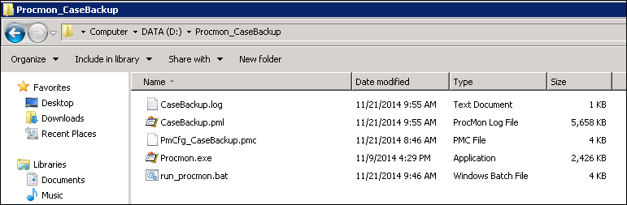  
  
CaseBackup.log:  
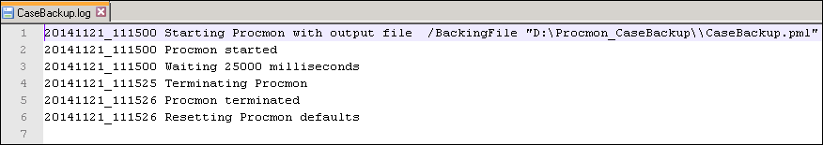  
  
CaseBackup.pml – The start of the case backup job:  
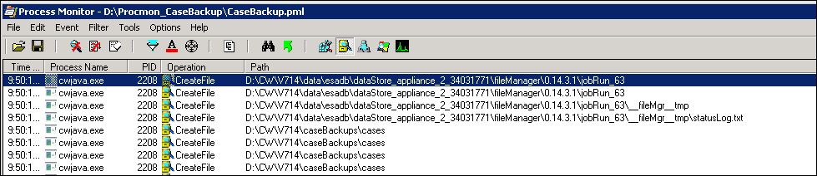  
  
CaseBackup.pml – Rreading the text files created by the use of custom fields of type “Long Text”:  
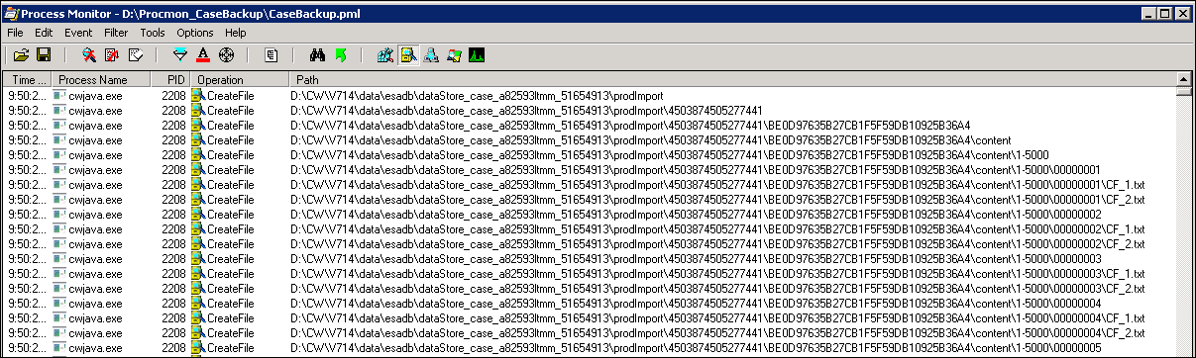  
  
CaseBackup.pml – Reading of the XML files generated for each document during the LFI discovery:  
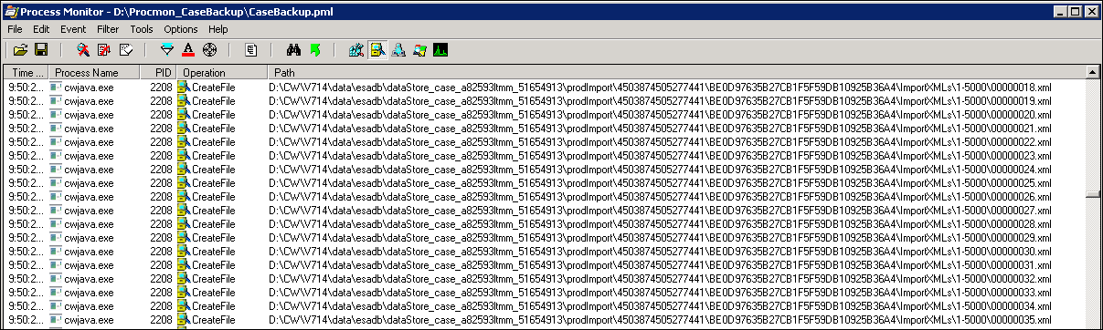  
  
CaseBackup.pml – Conversion of these files (via a Java IO stream) into compressed “.bak” files:  
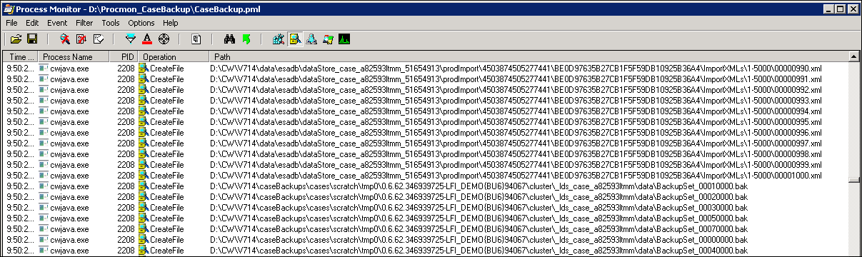  
  
CaseBackup.pml – End of the case backup:  
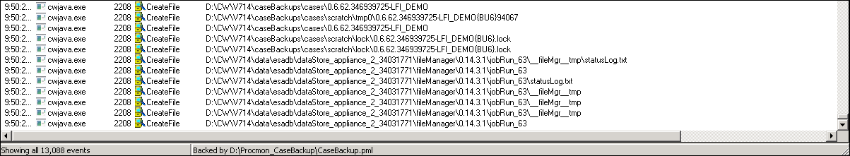

**Comments:**  
This example took only 15 seconds to complete, and created a Procmon output log file of size 5.6Mb. If a case backup takes 7 hours, I would therefore estimate a Procmon output log file of around 10Gb. The script can be edited to point the Procmon output log file to a UNC location. See the comments in the script.  
  
**END**